What we will be learning…

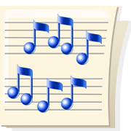in Kindergarten Music

August

Welcome to Kindergarten Music Class! We are going to have so much fun. We will learn actions and movements to new and known songs, how to follow directions and learn how to walk together in a circle.

By the end of this month we will be learning about **Fast** and **Slow.** Your children will have met **Racy Rabbit** and **Timmy Turtle**. Ask your child to sing you a song like Racy Rabbit or Timmy Turtle.

C:\Documents and Settings\teacher\Local Settings\Temporary Internet Files\Content.IE5\DKMH3VUL\MC900441409[1].wmf C:\Documents and Settings\teacher\Local Settings\Temporary Internet Files\Content.IE5\BKKJIBP9\MC900441417[1].wmf

We will talk about the different voices we can make: **talking**, **whispering**, **singing** and **yelling**. We know how to use them and which ones are good to use in school. Ask your child to share one of these voices with you. Ask your child to tell you about **“Three Little Muffins”** in the bakery shop.