What we are learning…
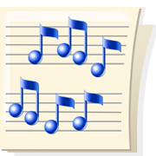
in 2nd Grade Music

January

The second grade music classes have finished the study to The Nutcracker Ballet. During this unit of study the students focused on each song’s large form and style: legato, staccato, or accented. These concepts will now be addressed in different musical settings so that children can gain a deeper understanding of how they apply to music.
Reading and writing music notation will continue. We will keep reviewing the pitches so, mi and la, and add the next pitch in the coming month. We will use instruments to perform the pitches so, mi and la.
Reading and writing rhythms will also be continued. We are practicing the rhythm of the half note in known songs and focusing on songs with 2 and 4 beat meters.
We will examine in depth the instruments in the orchestra. Students should be able to easily name the 4 instrument families in the orchestra. Students will learn how they produce a tone and name specific instruments in each of these families.
We will continue to practice all music skills and concepts we have previously studied while adding these more difficult music skills.

