What we are learning…
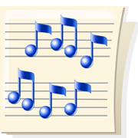
in 2nd Grade Music

August

Music Class is going to be a fun part of our day now that we are in 2nd Grade. We will be playing new and old games. We are reviewing what we learned in first grade, singing songs we know, and reviewing classroom expectations.

This month we will be reviewing beat, rhythm, form and pitch. We will write ta, titi and rest rhythms in known songs. We will practice writing music using so, mi and la. Ask your child what his/her favorite new song is.

We will be using our Music Folders to practice writing music. We will read songs from the board, SMART board and our music books. We will tell how songs are the same and different using a, b, and c. We used to use words like “apple, banana and cherry”, but we are big 2nd Graders now. Ask your child what that means.

