What we are learning…
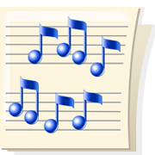
in 1st Grade Music

November

We are continuing to work on steady beat and rhythm. We are learning how our songs can be read using “ta” ( q), “ta-ti” ( sq), and “rest” ( Z ) . We have been using our Music folder and workbook to write our songs and are learning how they can match up.

We are learning new songs about our season of Thanksgiving and are showing some of our songs by using Sign Language. This is the way deaf people learn to communicate and we are excited to learn some of those signs for our songs.

Some of our music time is involved with learning the song that each class is preparing for the First Grade program. Watch for more information and we look forward to performing for you.

